

Advanced Web Design and Development

Proposed Logbook Report
Cover Page
Student Details
- Student Name – Angela Gathoni
- Admission Number – BBIT/2024/73746
- Course/Class – Year 3
- Unit Code: BIT3208
- Unit Name: Advanced Web Design and Development
- Lecturer Name – Michael Nyoro
- Semester/Academic Year – Sem 2

Project Details
- Project Title – Gamehub Equipment E-commerce
- Selected Technologies:
  - PHP + MySQL

Online Portfolio / GitHub Link
https://github.com/Angie0pp/gamehub.git

Table of Contents
1
Advanced Web Design and Development 1
Proposed Logbook Report 1
Project Details 1
Week 1: Local Environment Setup 3
Installation and Testing of Local Development Environment 3
Localhost Test Page 4
Dashboard Php 7
Github pages 8
Week 2: Wireframes and GUI Design 9
Title 9
User Interface Planning and System Design 9
Fig 1: Hand-drawn Wireframe 9
Fig 2: Dashboard Layout Design 9
Week 3: JavaScript and PHP Basics 10
Implemented JavaScript basics 10
JavaScript Form Validation 10
Password Strength Checker 10
Fig 3: PHP Syntax Practice 11
11
WEEK 4: PHP Concepts 11
Server-Side Programming 11
Login form screenshots 11
11
Folder structure screenshots 13
WEEK 5: Database Components and CRUD Operations 14
Introduction to Databases 14
CRUD operation screenshots 15
LOGIN DATABASE INTEGRATION 16
GitHub updates 18

Week 1: Local Environment Setup

Installation and Testing of Local Development Environment
Fig 1: Installation of XAMPP

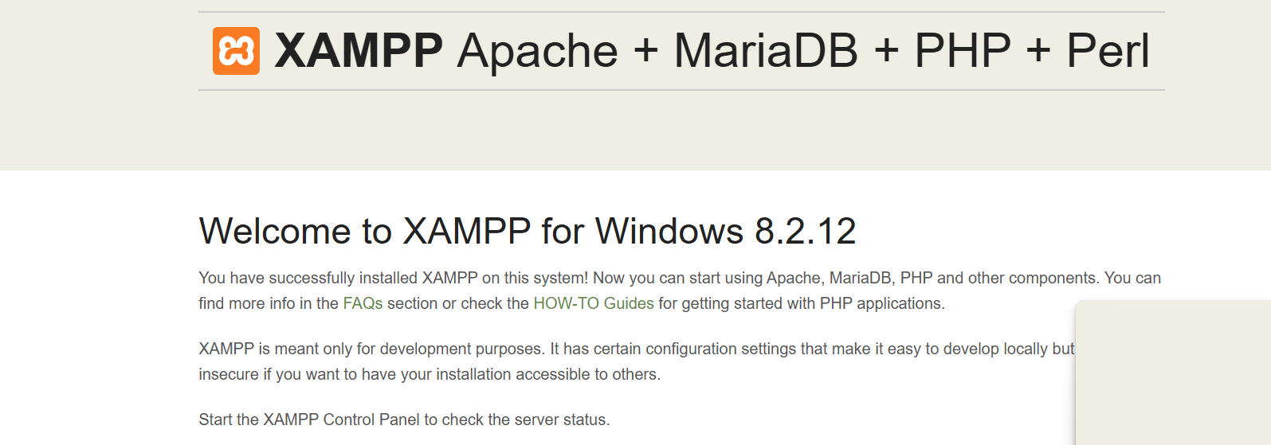

Fig 2: Apache and MySQL Running
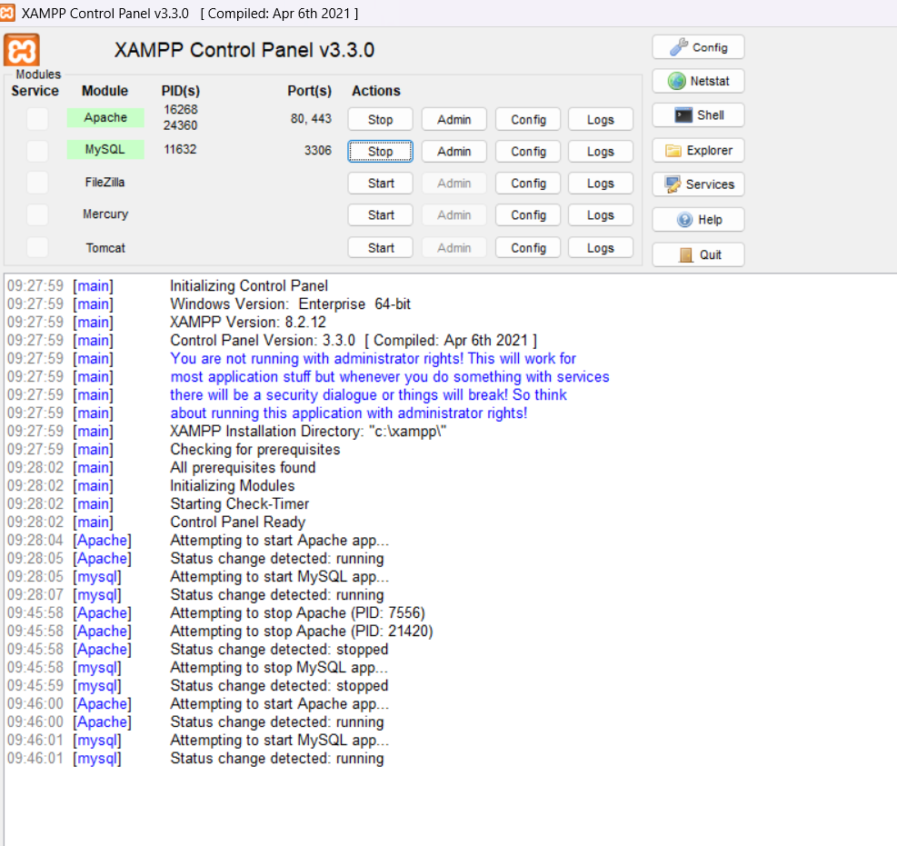

Localhost Test Page

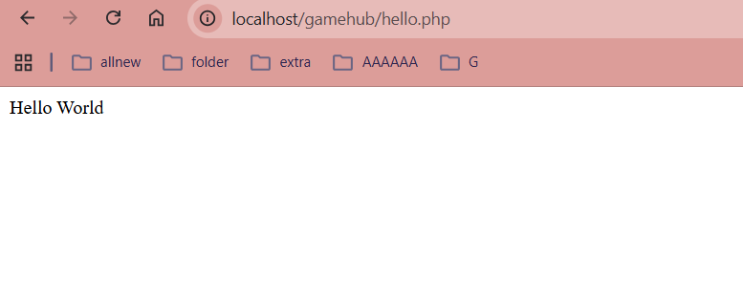

Fig 4: Hello World Test
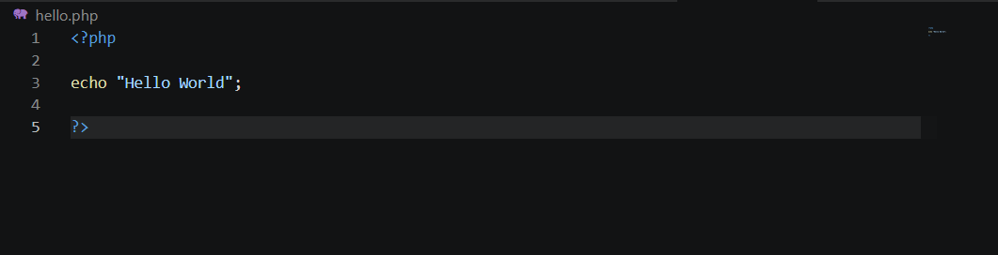
Fig 5: Database Connection Test

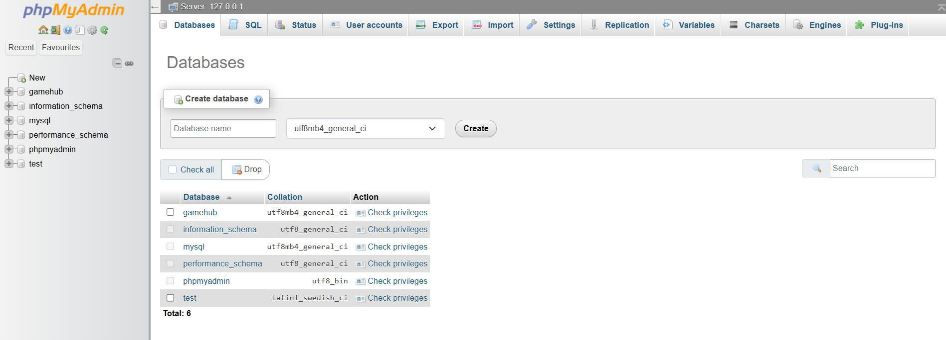
Games Table
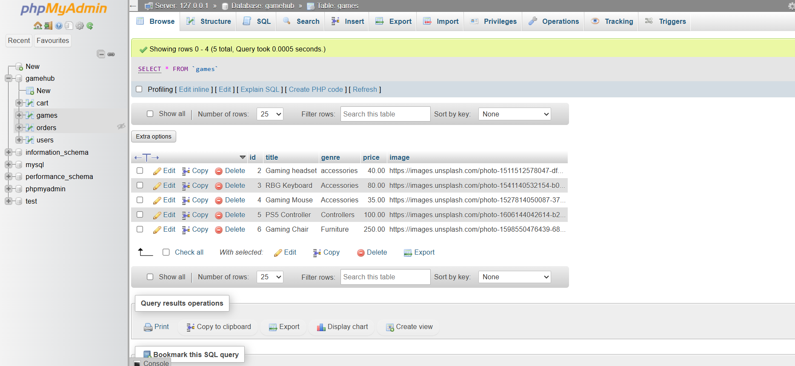
Users Table
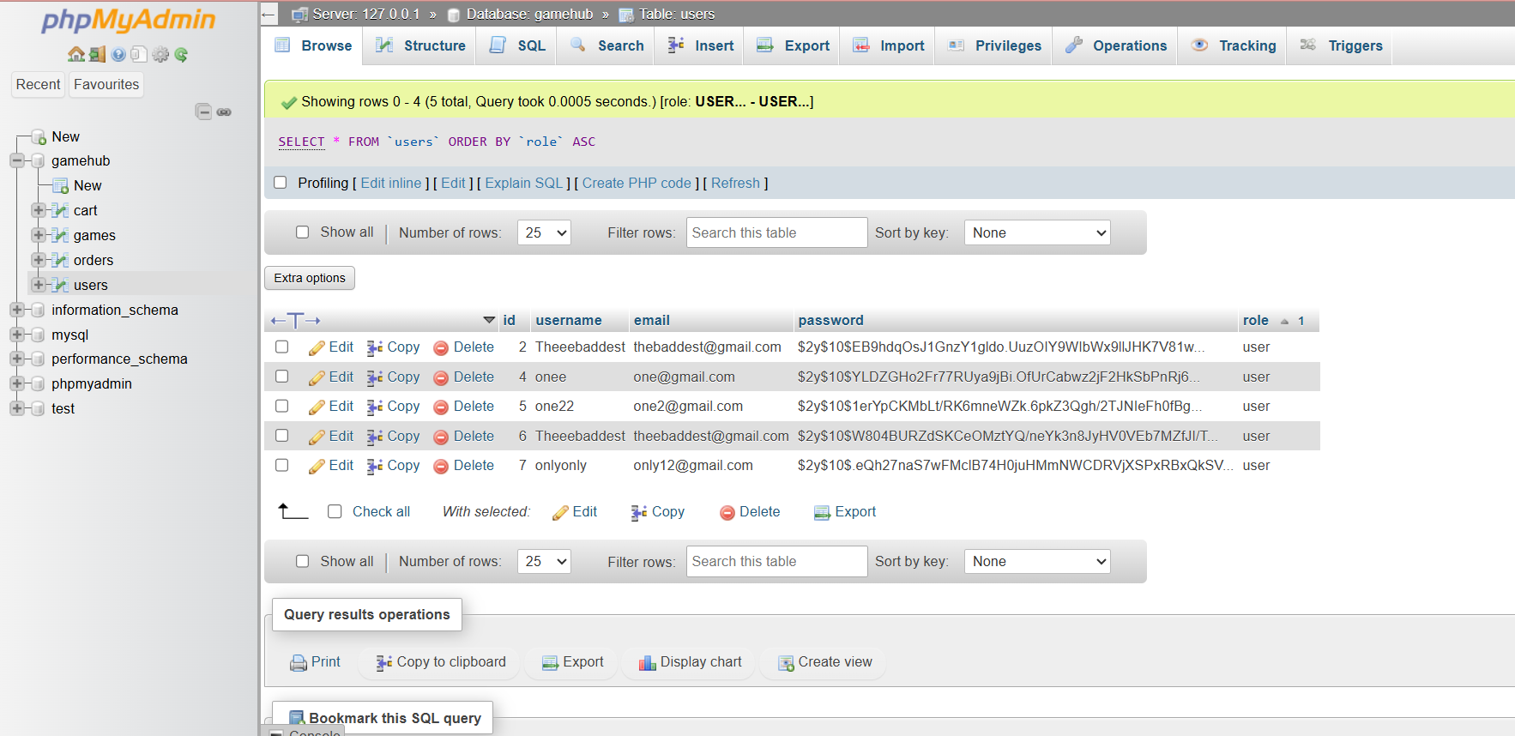
Fig .6 Vs Code Project
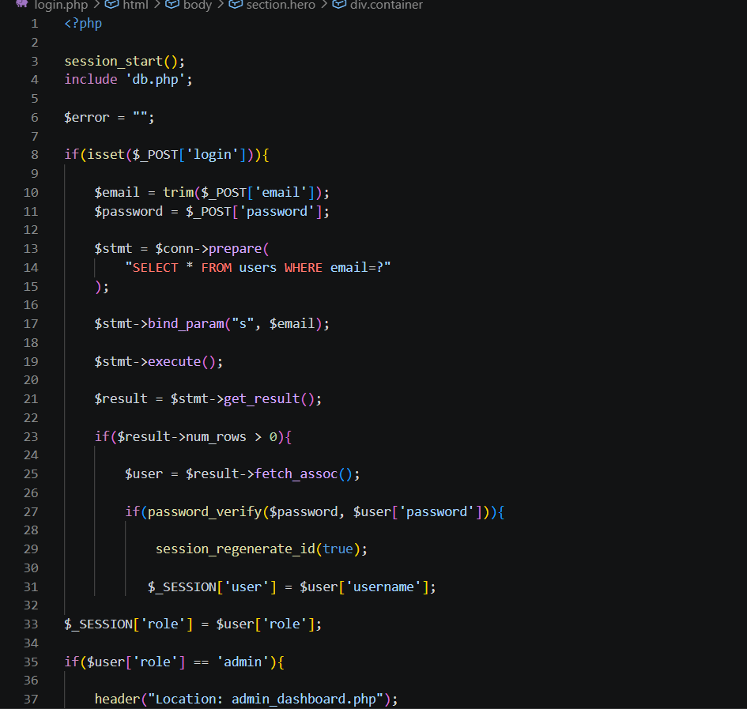

Dashboard Php
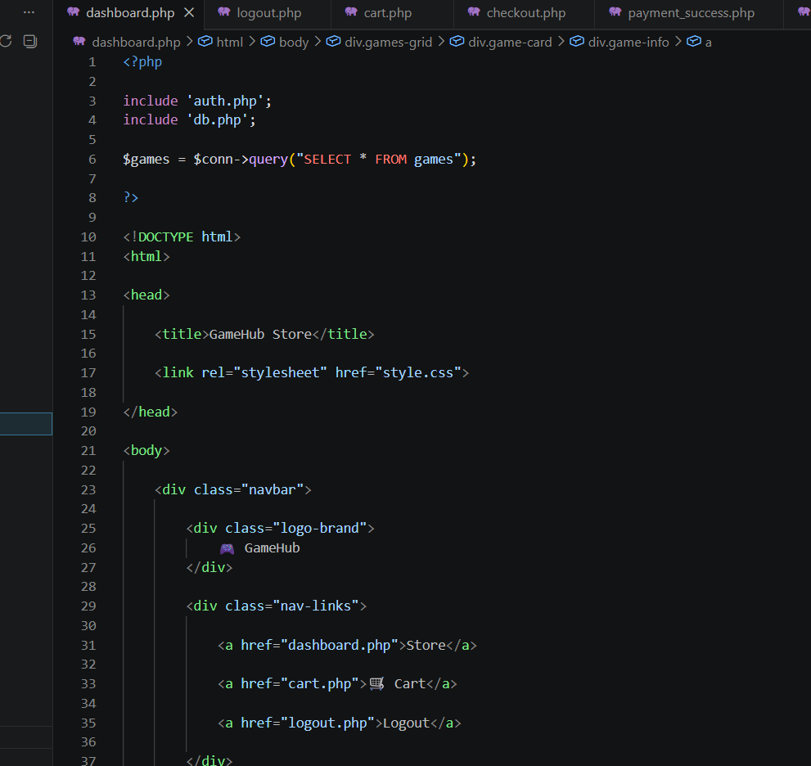

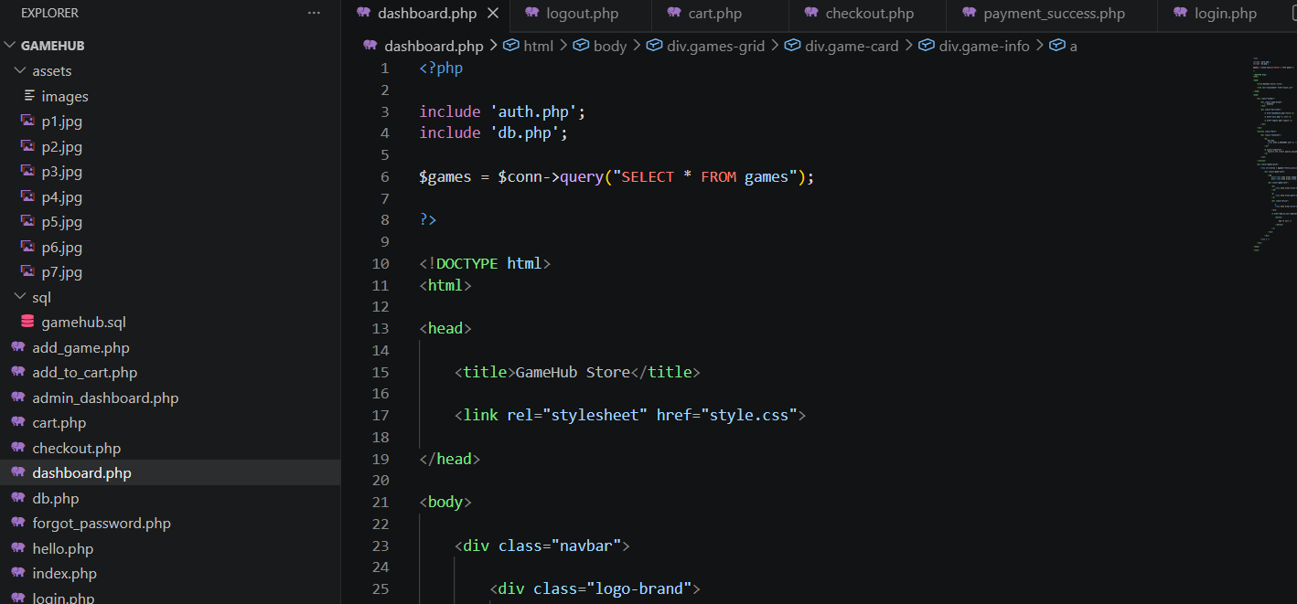

Github pages
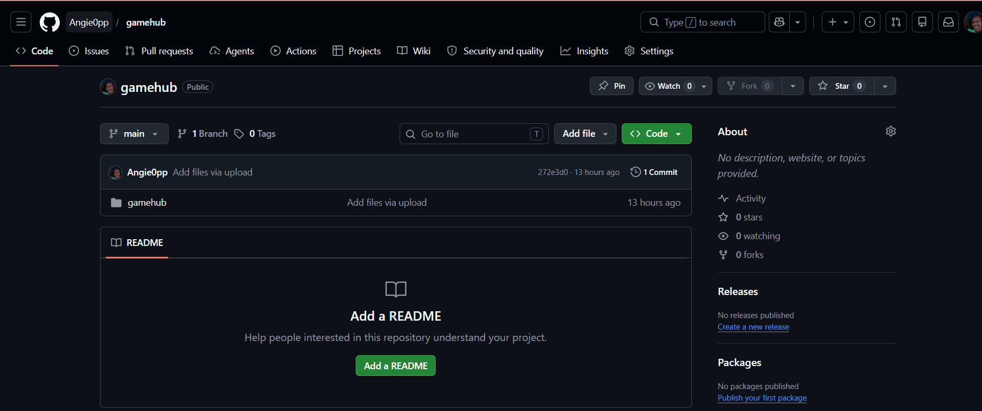

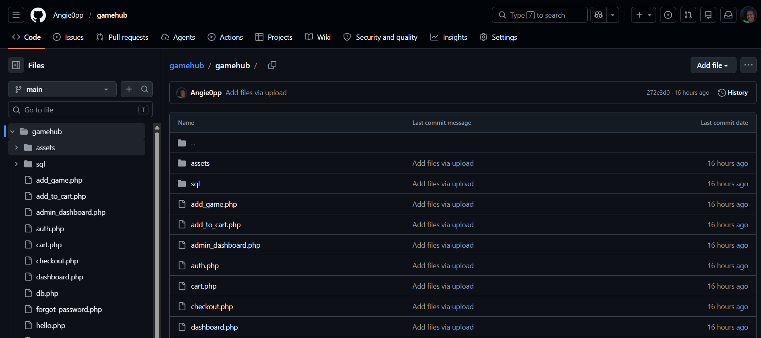

Week 2: Wireframes and GUI Design

Title

User Interface Planning and System Design

Fig 1: Hand-drawn Wireframe
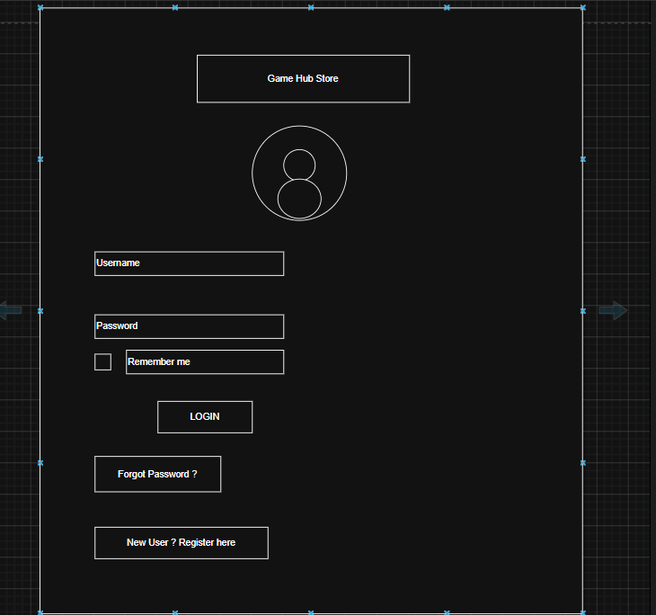

Fig 2: Dashboard Layout Design

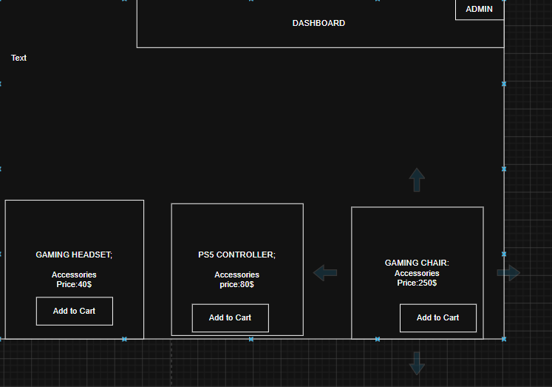

Week 3: JavaScript and PHP Basics

Implemented JavaScript basics

JavaScript Form Validation
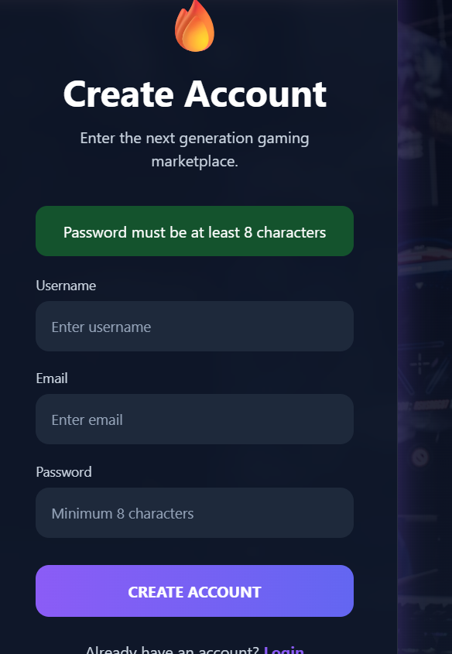

Password Strength Checker
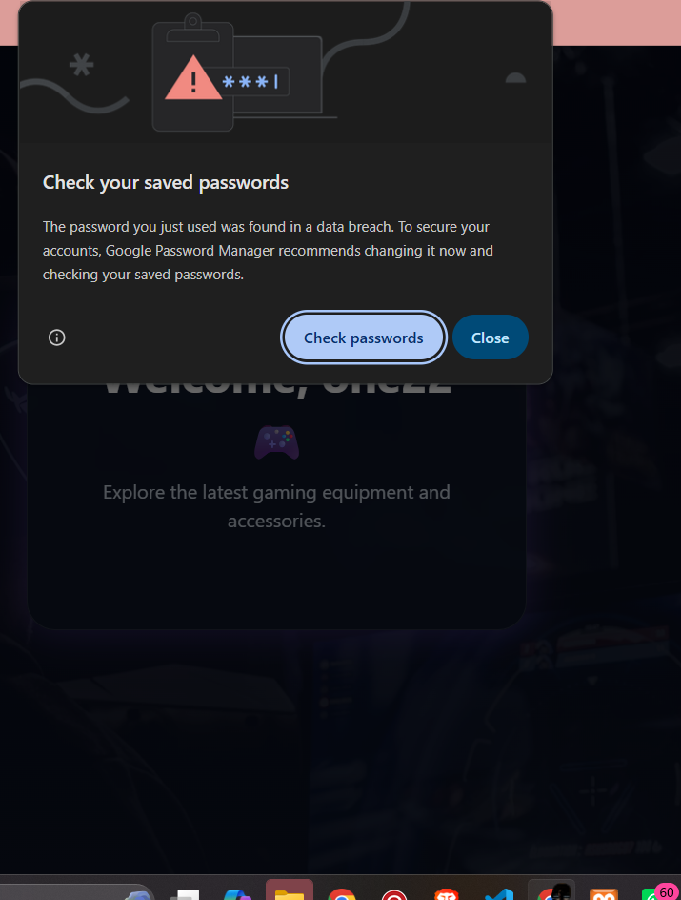

Fig 3: PHP Syntax Practice

WEEK 4: PHP Concepts

Server-Side Programming

Login form screenshots

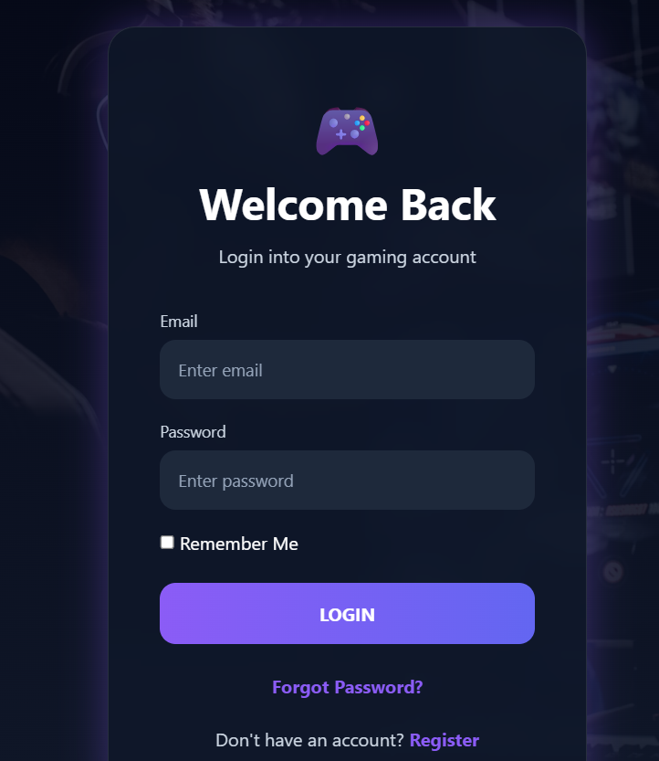

Form validation screenshots
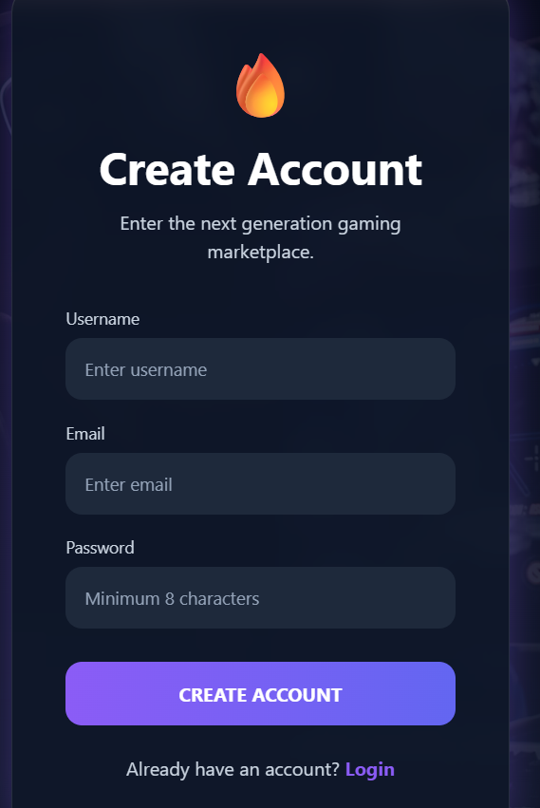
PHP processing screenshots

Folder structure screenshots
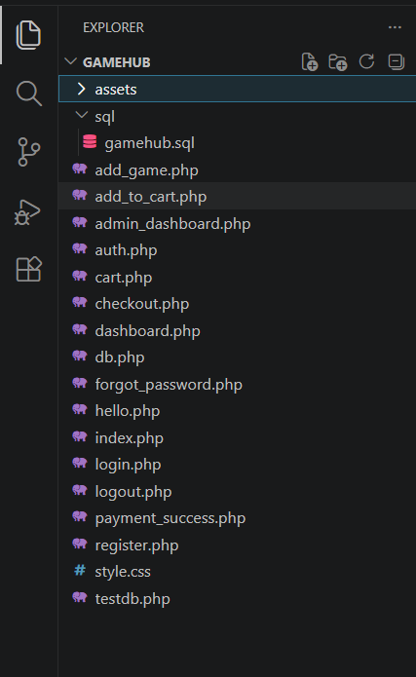
Database connection screenshots
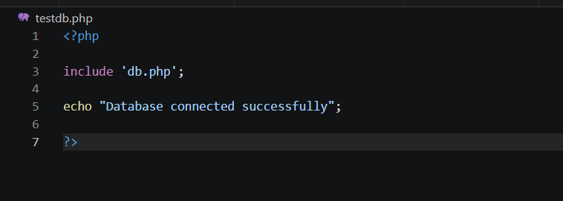
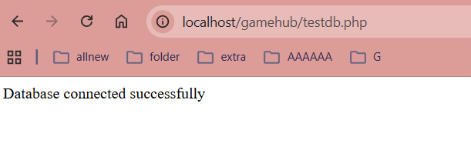

Code snippets
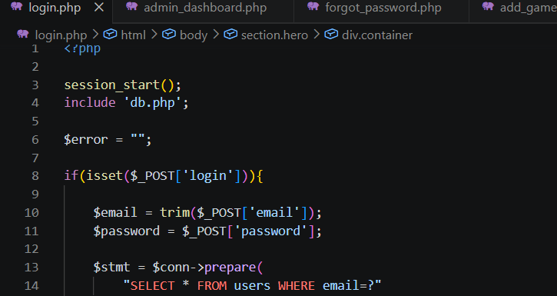

WEEK 5: Database Components and CRUD Operations

Introduction to Databases
Database screenshots
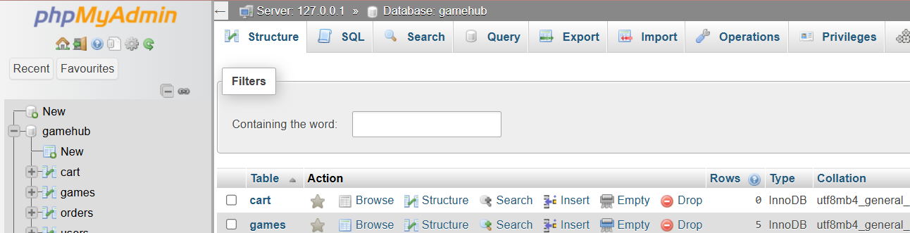
Table creation screenshots
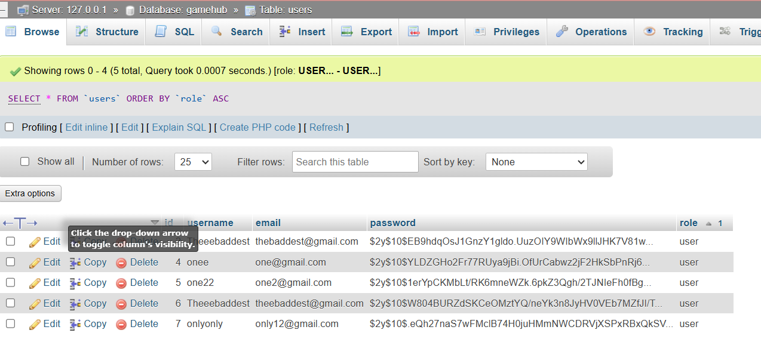

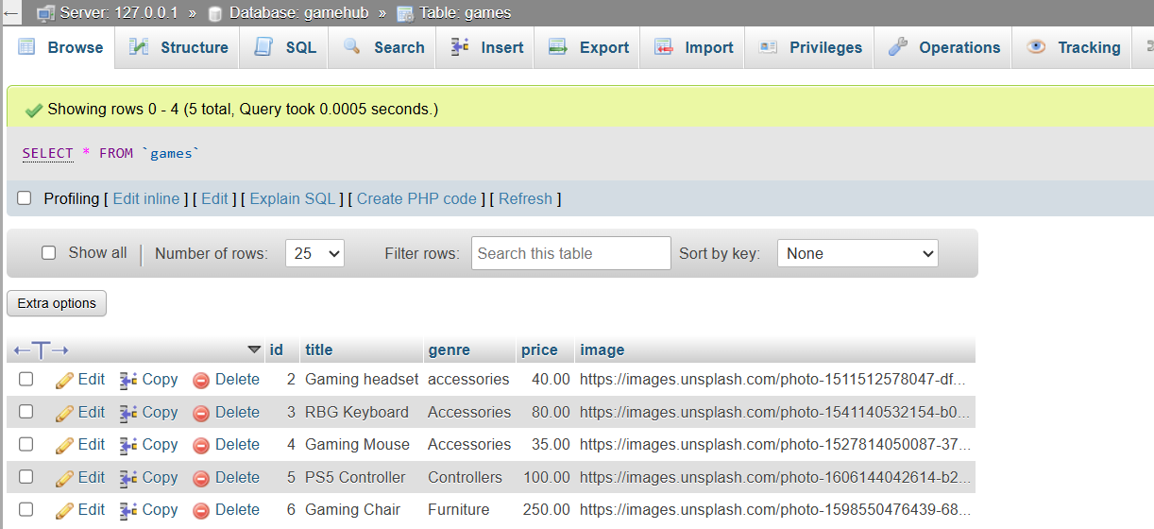

CRUD operation screenshots
CREATE
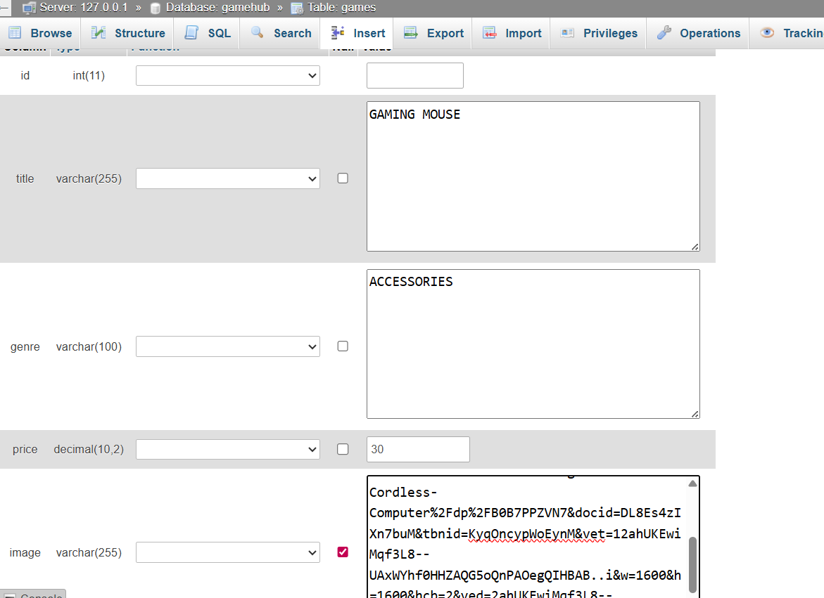

UPDATE
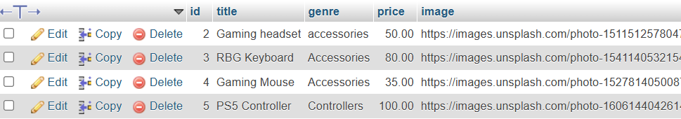

LOGIN DATABASE INTEGRATION
Register php
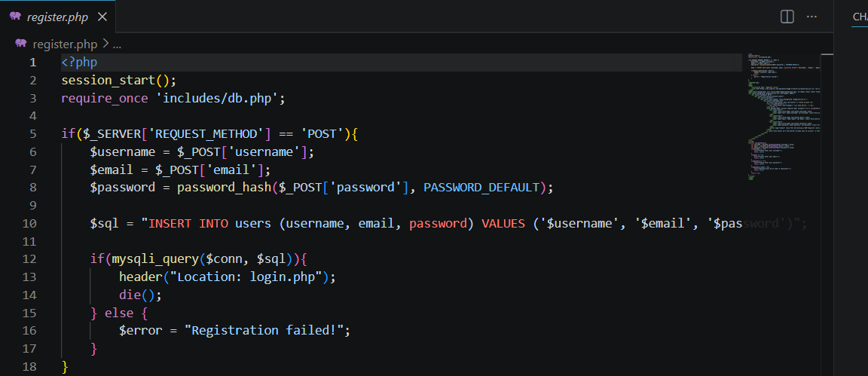
Login php
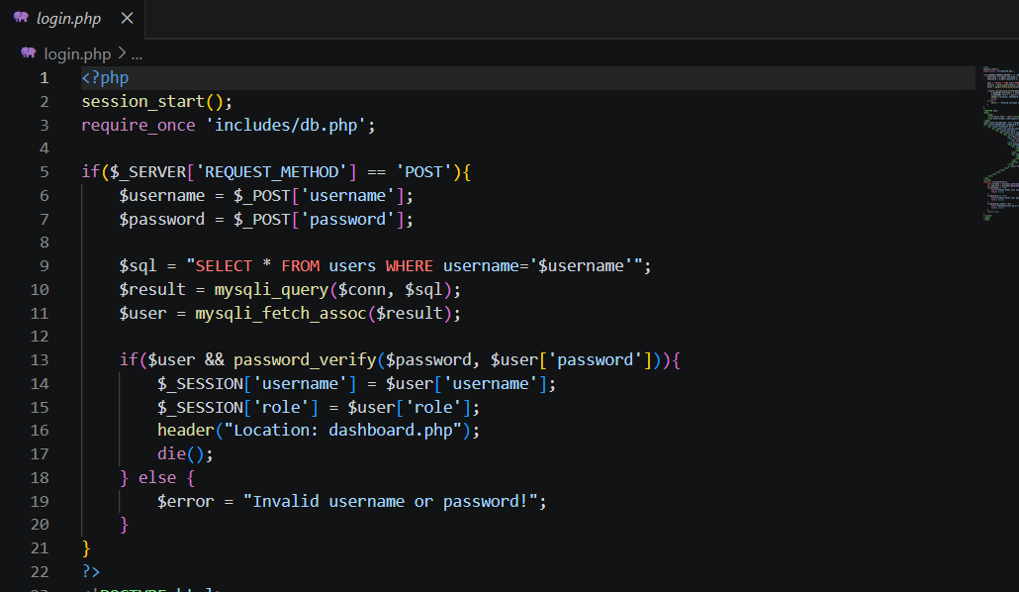

Website database intergration
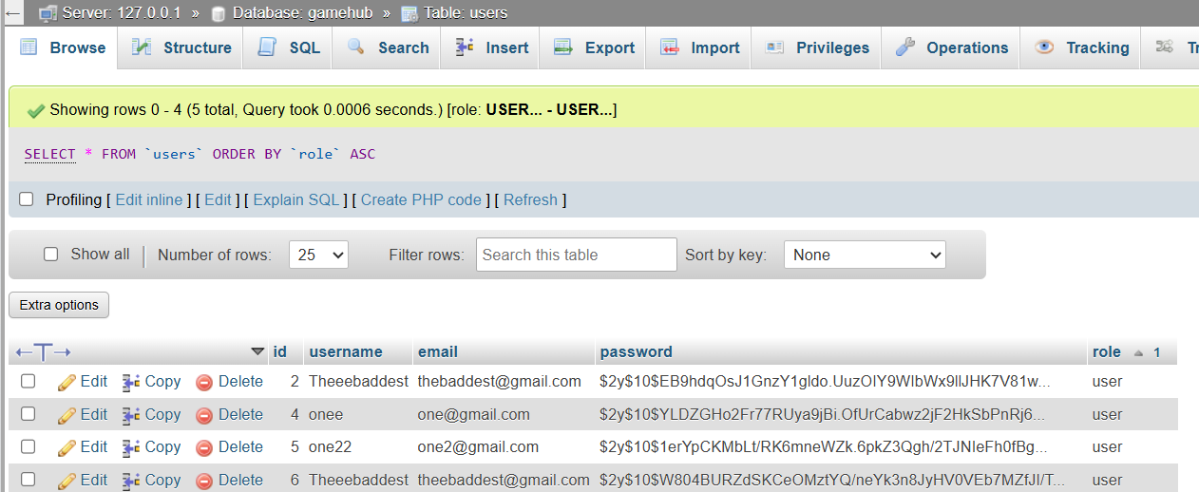
SQL query
Users SQL
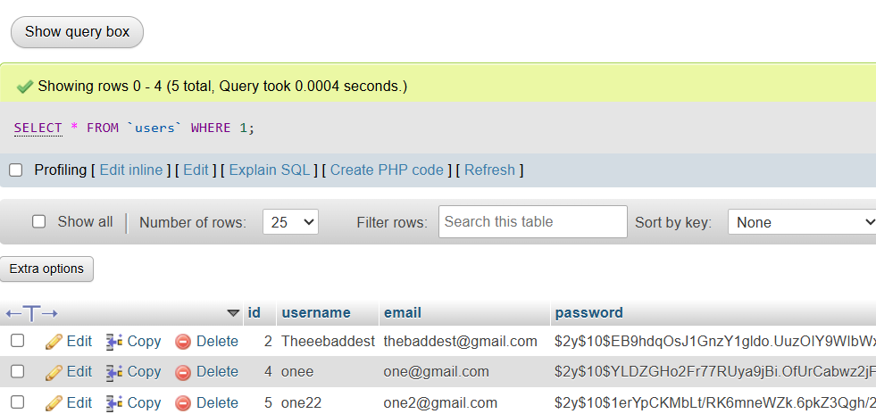
Games SQL
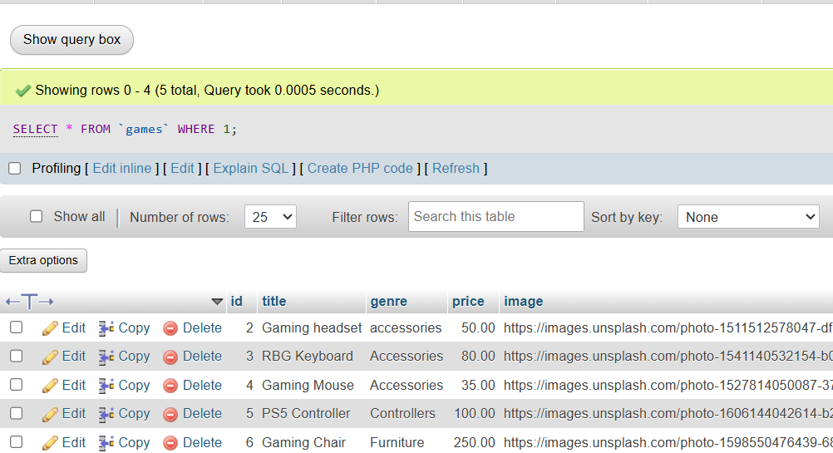

GitHub updates
